

Research

Cyber Security- Logbook

**Name and Surname:** Avile Bantwini

**ID Number**: 0106256053088

**Logbook Topic**: Research topic

**Task No:** 02

**Unit Standard Number:** 114076



Table of Contents

**Implementing Security Measures for Desktop and Multi user Systems: Strategies, Challenges, and Best Practices.** 2

Task 1: What Topic did you choose and why 2

Task 2: How did you Plan Your Research? What steps did you follow? 2

Task 3: Describe the Research Process. What Sources Did You Use? 2

Task 4: How did you Present Your Findings? What tools did you use? 3

**Introduction** 4

Security Strategies for Desktop Systems 4

Security Strategies for Multi-User Systems 4

Challenges in Implementing Security Measures 5

Best Practices 5

Case Studies and Expert Insights 5

**Conclusion** 5

References 6

Power-point Slides Evidence 7

# **Implementing Security Measures for Desktop and Multi user Systems: Strategies, Challenges, and Best Practices.**

## Task 1: What Topic did you choose and why

The chosen topic for this research is ‘Implementing Security Measures for Desktop and Multi user Systems: Strategies, Challenges, and Best Practices’. The rapid advancement of technology and the increasing interconnectedness of systems have significantly elevated the risk of cyber threats. These threats include malware attacks, data breaches, and unauthorized access to sensitive information. Securing desktop and multi user system is critical to protecting personal data, maintaining organizational integrity and ensuring operational continuity. According to the 2023 cyber security threats report by Symantec, cyberattacks have increased by 40% compared to the previous year, highlighting the urgent need for robust security measures. This topic was selected to explore effective security strategies, understanding the challenges in their implementation, identify best practices that can help safeguard sensitive information and maintain operational integrity.

## Task 2: How did you Plan Your Research? What steps did you follow?

The research was planned to achieve the following objectives: Identify key security strategies for desktop and multi-user systems, understand the challenges in implementing these security measures, and recommend best practices for enhanced security. The planning process began with defining these objectives clearly. The next step is comprehensive literature review which I conducted by searching academic databases such as Research gate, google scholar, and IEEE Explore to find relevant papers and articles on cyber security measures. Industry reports from McAfee and Cisco were also reviewed to understand current trends and threats in cybersecurity.

Information was then gathered from these sources, focusing on security strategies, challenges, and best practices. The gathered information was organized into relevant sections: Security Strategies, Challenges, Best Practices, Case studies, and Expert insights. An outline of the research was created, followed by drafting each section based on the organized information. The draft was reviewed for completeness and clarity, and revisions were made based on the feedback from peers.

## Task 3: Describe the Research Process. What Sources Did You Use?

The research process involved conducting a through literature review, collecting data from various sources, and organizing the information into structured report. The sources used include academic papers industry reports, credible online sources, and books. IEEE explore provide me papers on desktop and multi-user system security, Research gate offered me articles and conference papers on cybersecurity strategies, and google scholar was used to find academic papers and theses on the topic.

Industry reports from McAfee and Cisco were instrumental in understanding current trends and threats in cybersecurity. Books like “Cybersecurity for Dummies, The Art of Deception, and Security in Computing” were also referenced to gather comprehensive information on cybersecurity measures.

## Task 4: How did you Present Your Findings? What tools did you use?

The findings were presented using tools such as PowerPoint, Google Slides and Canvas. These tools were chosen for their effectiveness in creating visually appealing and engaging presentations. The presentation was structured with an introduction slide, followed by detailed strategy slides, challenge analysis slides, best practices slides, case studies and expert insights slides, and conclusion slide, and Q&A slides.

PowerPoint and Google slides were used to create the presentation slides, while Canvas was used for designing visual aids and enhancing the visual appeal of the slides. The presentation was rehearsed to ensure a smooth flow and effective communication of key points. The finding were then delivered to peers and feedback was collected on the presentation’s content, clarity, and delivery.

**Full Research Report**

# **Introduction**

The rapid advancement of technology and the increasing interconnectedness of systems have significantly elevated the risk of cyber threats. These threats include malware attacks, data breaches, and unauthorized access to sensitive information. Securing desktop and multi-user system is critical to protecting personal data, maintaining organizational integrity, and ensuring operational continuity. According to the 2023 Cybersecurity Threat report by Symantec, cyberattacks have increased by 40% compared to previous year, highlighting the need for robust security measures. The objectives of this research are to identify key security strategies for desktop and multi-user best practices for enhancing security.

## Security Strategies for Desktop Systems

Anti-virus and anti-malware software are essential tools in defending against malicious software. These programs detect, quarantine, and remove harmful code before it can cause damage. Popular tools like Norton and McAfee offer comprehensive protection by continuously scanning for threats and updating their databases with the latest malware signatures (WAN, 2020). Firewalls act as a barrier between a trusted internal network and untrusted external networks, such as the internet. They monitor incoming and ongoing traffic and enforce security policies to block unauthorized access. Firewalls can be hardware based, software based, or a combination of both (Hancok, 2019).

Regularly updating software to fix vulnerabilities is crucial in preventing exploitation by cybercriminals. Patch management tools like Windows Update and Windows Server Update Services (WSUS) automate the process of applying updates to ensure systems remain secure. Encryption transforms readable data into an unreadable format, which can only be decrypted by authorized parties. This ensures that even if data is intercepted, it remains secure. Tools like BitLocker provide robust encryption solutions for desktop systems. User authentication verifies the identity of individuals accessing a system, while authorization determines their level of access. Multi-factor authentication adds an extra layer of security by requiring additional verification steps. Role-based access control (RBAC) ensures that users only have access to the resources necessary for their role (Boonkrong, 2020).

## Security Strategies for Multi-User Systems

Implementing the principle of least privilege ensures that users have the minimum level of access necessary to perform their duties. Directory services like Active Directory manage user identities and access permissions, enhancing security in multi-user environments. Securing network communications is vital in protecting data transmitted between systems. Virtual Private Networks and secure Wi-Fi configurations prevent unauthorized access and eavesdropping on network traffic. Data backup and recovery strategies ensure that data can be restored in the event of a loss or corruption. Secure data storage solutions, such as encrypted drives and cloud storage with strong security measures, protect data integrity and availability (Ruj, 2016). Continuous monitoring for unusual activities helps detect and respond to potential security incidents promptly. Tools like Splunk provide comprehensive auditing capabilities to track and analyze system activities.

## Challenges in Implementing Security Measures

Budget and personnel limitations can hinder the implementation of comprehensive security measures. Organizations must prioritize their security investments and optimize the use of available resources. User behavior plays a critical role in maintaining security. Despite technical safeguards, human error remains a significant vulnerability. Educating users about security best practices and fostering a culture of compliance is essential. The cyber threat landscape is constantly evolving, with new threats emerging regularly. Staying updated with the latest threats and adapting security measures accordingly is a continuous challenge. Security measures should not compromise the usability of systems. Striking the right balance between security and user convenience is crucial to ensure productivity while maintaining robust security (Roy, 2024).

## Best Practices

Regular training and awareness programs help users recognize and respond to security threats. Effective training should cover topics such as phishing attacks, safe browsing practices, and password management. An incident response plan outlines the steps to be taken in the event of a security breach. It includes identifying the incident, containing the damage, eradicating the threat, and recovering from the attack. Regularly reviewing and updating security policies ensures that they remain effective against new threats. Implementing advanced monitoring tools provides real-time insights into potential security issues. Zero Trust Architecture assumes that threats can exist both inside and outside the network. It requires verifying every access request as though it originates from an open network, thereby minimizing the risk of unauthorized access (Rouwet, 2022).

## Case Studies and Expert Insights

A multinational corporation implemented a multi-layered security strategy, including MFA, encryption, and regular security training. This resulted in a 50% reduction in security incidents. A healthcare organization adopted Zero Trust Architecture, which significantly improved its security posture and compliance with regulatory requirements. John Dube, a cybersecurity expert, emphasizes the importance of maintaining an adaptive and proactive approach to cybersecurity. Continuous learning and updating security measures are key to staying ahead of threats (wilson, 2014).

# **Conclusion**

This research identified key security strategies for desktop and multi-user systems, explored common challenges, and proposed best practices. Anti-virus software, firewalls, encryption, and MFA are essential for desktop security, while access control mechanisms, network security, and continuous monitoring are vital for multi-user systems. Emerging trends in cybersecurity, such as AI-driven threat detection and advanced encryption technologies, present new opportunities for enhancing security. Future research should focus on these areas to develop more effective security measures.

# References

Boonkrong. (2020). Multi Factor Authentication. *Authentication and acess Control*.

Hancok. (2019). Internet Firewall. *Network Security* .

Rouwet. (2022). Open radio access network overview. *Open Radio Access Network (O-RAN) Systems Architecture and Design* .

Roy. (2024). A General Walkthrough of the Cyber-Physical Systems Concerning Security Threats and Safety Measures. *Intelligent Security Solutions for Cyber-Physical Systems*.

Ruj, S. &. (2016). Publicly Verifiable Secure Cloud Storage for Dynamic Data Using Secure Network Coding. *Proceedings of the 11th ACM on Asia Conference on Computer and Communications Security*.

WAN. (2020). A Robust Cloud Security Architecture based on Distributed Servers, User Authentication, and AES, Blowfish Encryption Techniques. *Journal of Advanced Research in Dynamical and Control Systems*.

wilson. (2014). Control-System Cybersecurity: Staying Ahead of Evolving Threats. *Journal of Petroleum Technology*.

# Power-point Slides Evidence

1**.1**

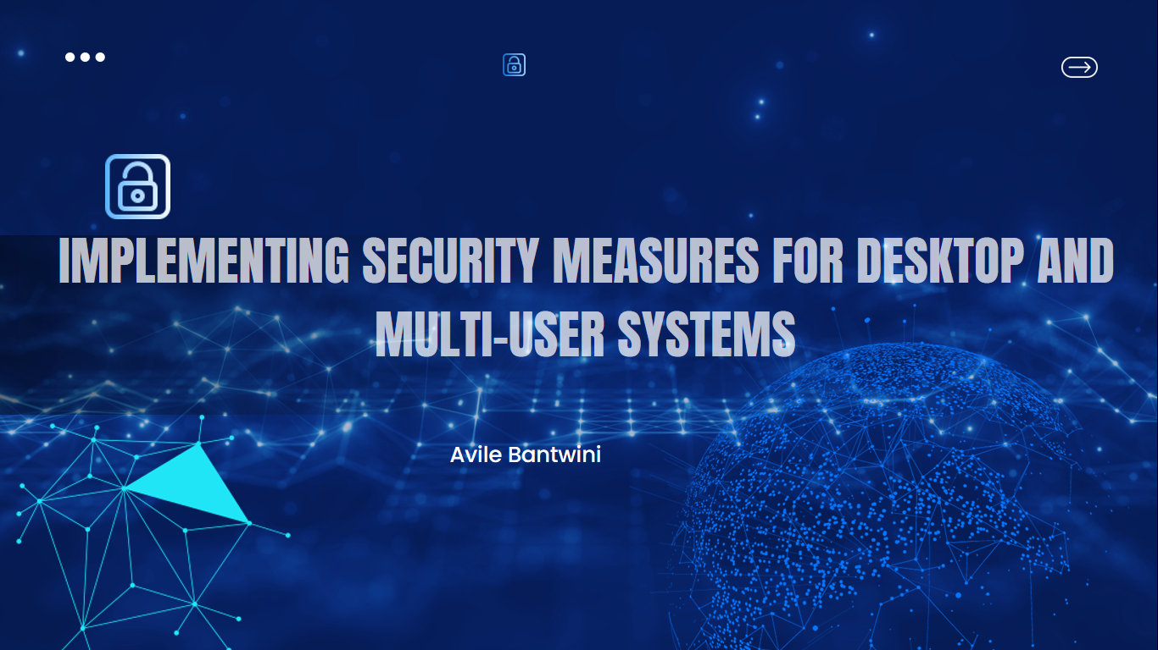

1.2 **Introduction-** This is an overview of my research

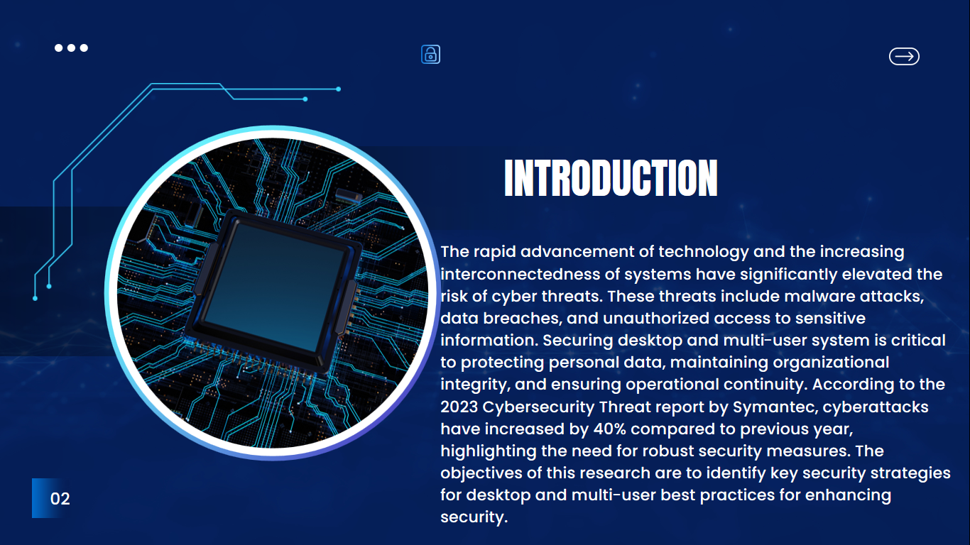

1.3. **These are the Security Strategies for desktops systems**

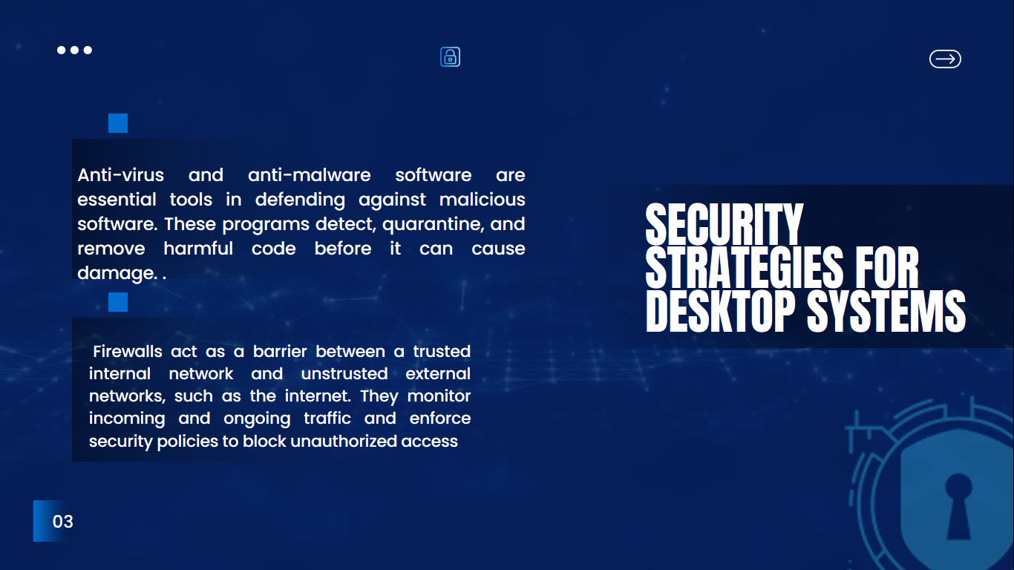

1.4 **Security Strategies for Multi user system**

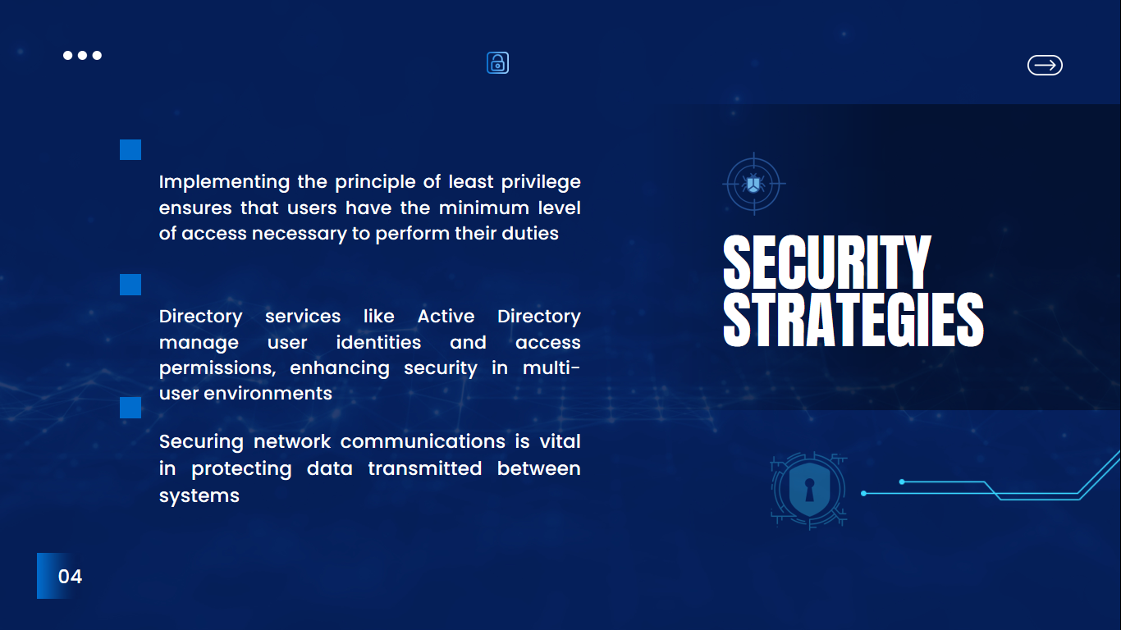

1.5**. Challenges in Implementing Security Measures**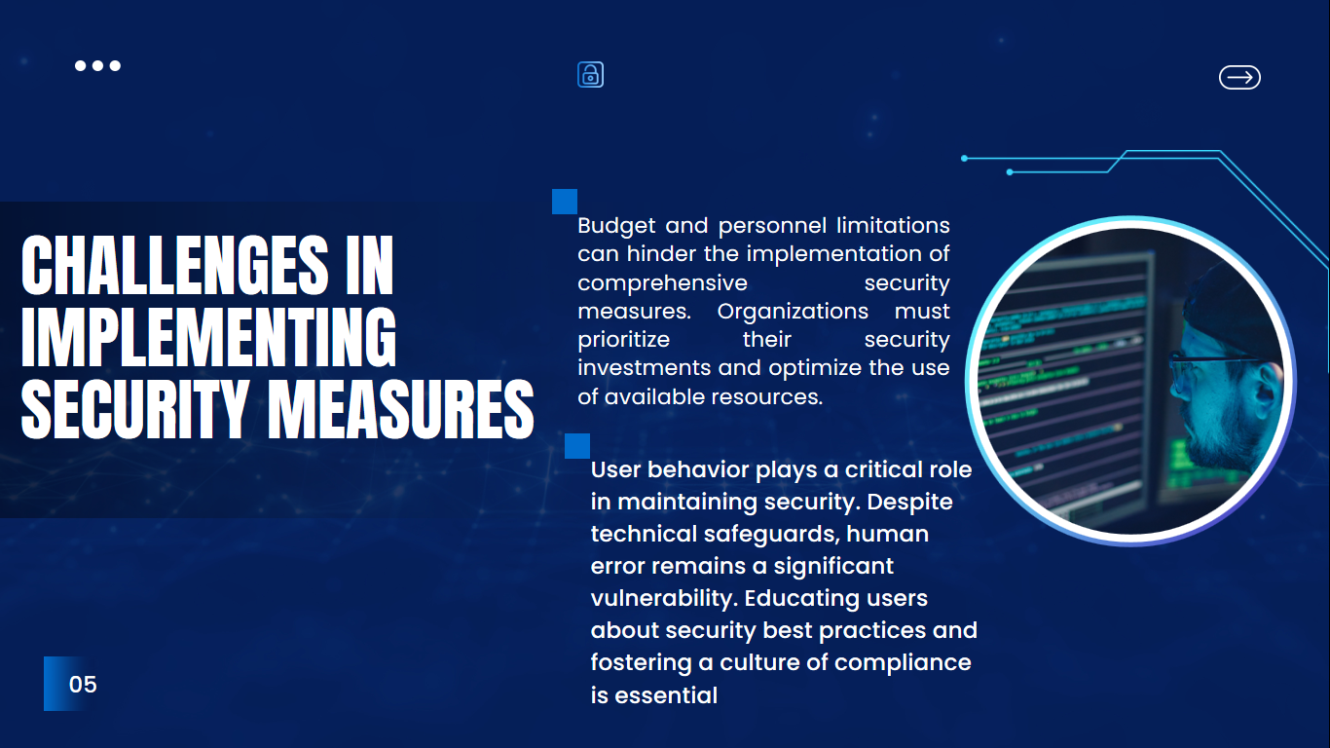

**1.6 Best Practices**

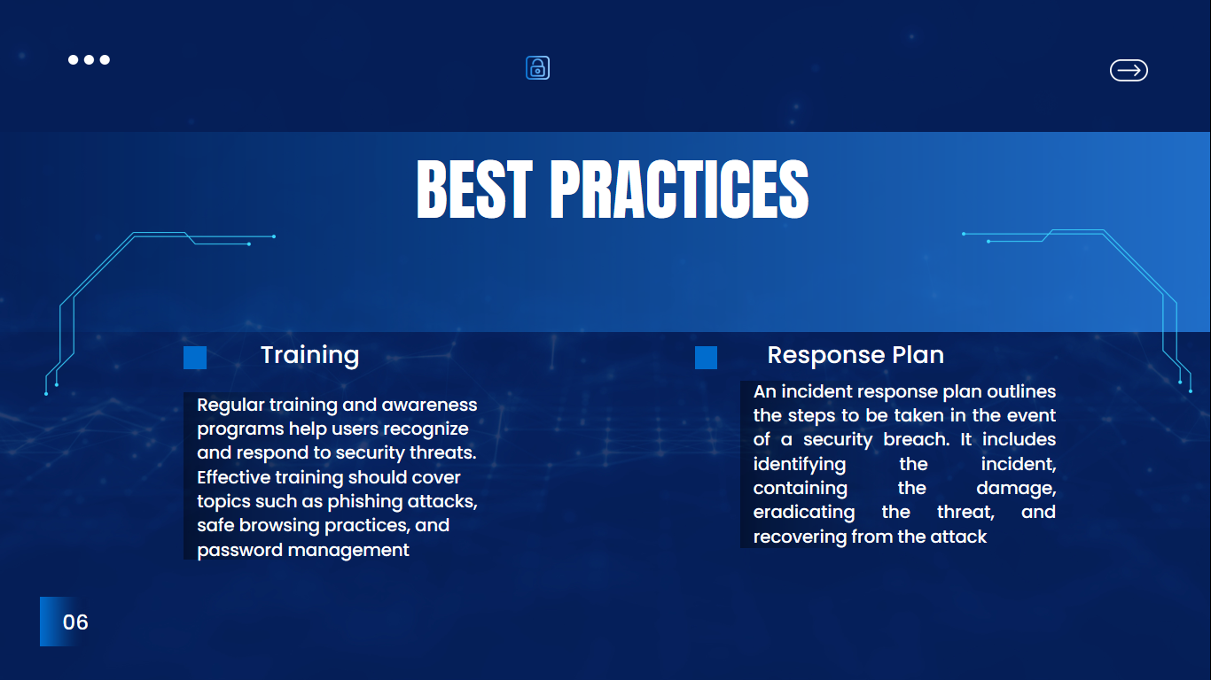

1.7. **Case Studies and expert insights**

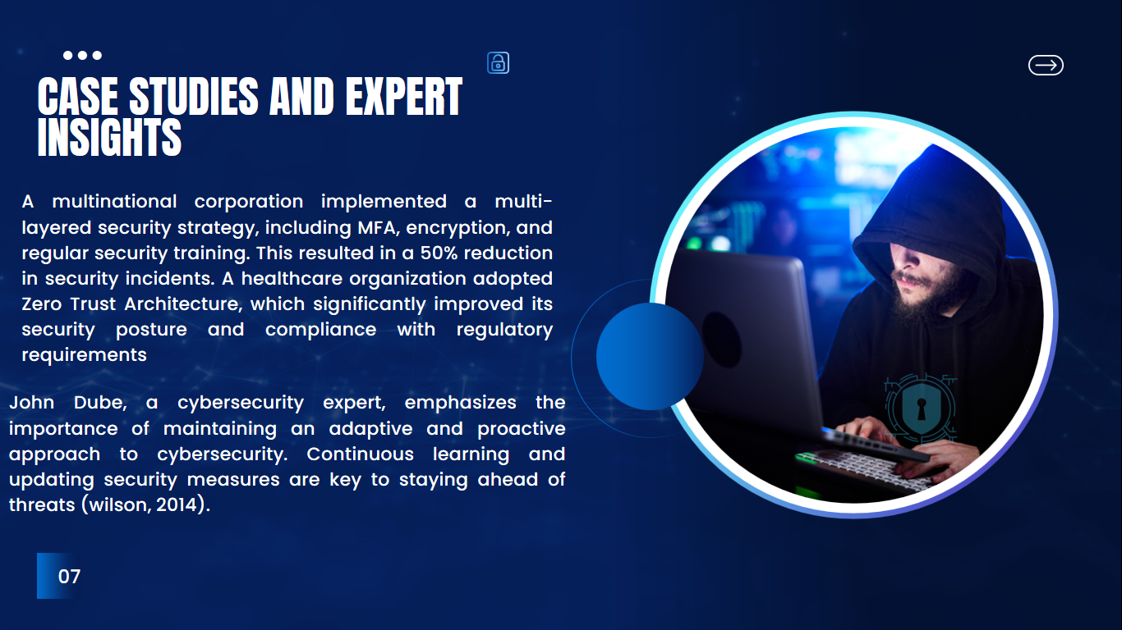

**1.8 Conclusion**

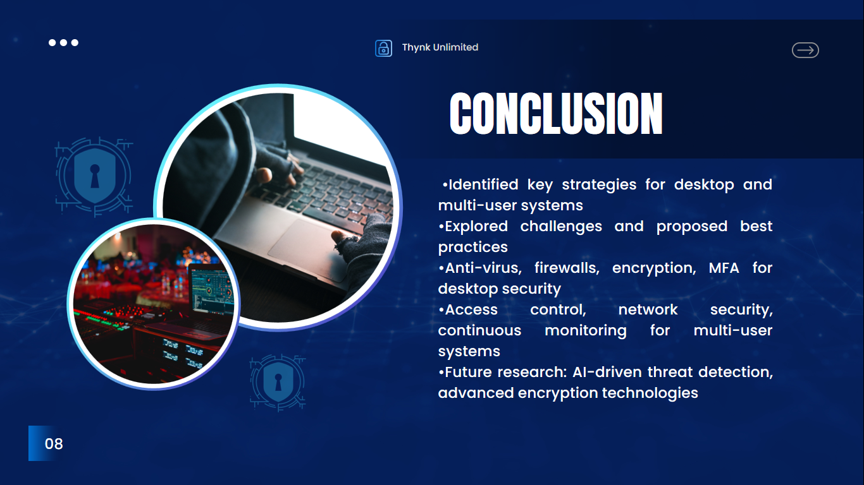

**1.9 Reference**

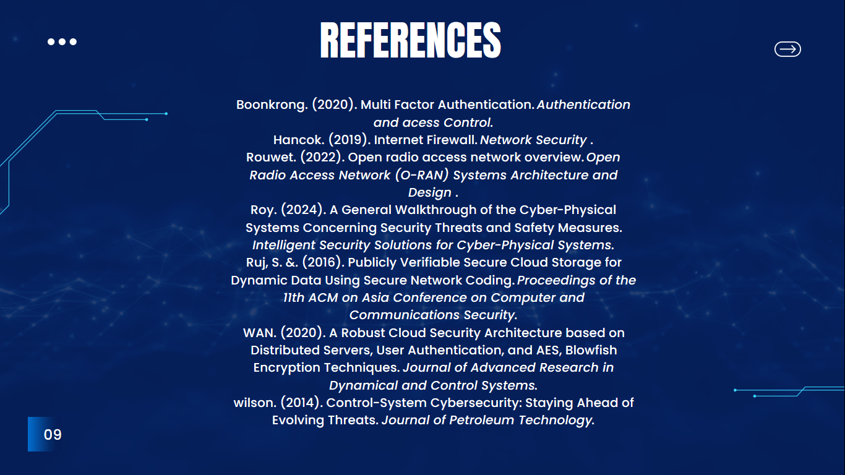

1.10. **Thank you and welcome**

